**----CORE JAVA ASSIGNMENT----**

**DATE-15/06/2023**

1 .//Write an application that sums the integers from

//1 to n. Save the file as SumofIntegers.java.

**package DucatAssignments;**

**import java.util.Scanner;**

**public class SumofIntegers {**

**public static void main(String[] args) {**

**System.out.println("Enter the number :");**

**Scanner sc=new Scanner(System.in);**

**int n=sc.nextInt();**

**int sum = calculateSum(n);**

**System.out.println("The sum of integers from 1**

**to " + n + " is: " + sum);**

**}**

**public static int calculateSum(int n) {**

**int sum = 0;**

**for (int i = 1; i <= n; i++)**

**{**

**sum += i;**

**}**

**return sum;**

**}**

**}**

**OUTPUT**

**Enter the number :**

**100**

**The sum of integers from 1 to 100 is: 5050**

2 **.//Write an application to calculate how many days it is from today**

**until the end of the current year.Save the file as YearEnd.java.**

**package DucatAssignments;**

**import java.time.LocalDate;**

**import java.time.temporal.ChronoUnit;**

**public class YearEnd {**

**public static void main(String[] args) {**

**// Get the current date**

**LocalDate currentDate = LocalDate.now();**

**// Get the last day of the current year**

**LocalDate endOfYear = LocalDate.of(currentDate.getYear(), 12, 31);**

**// Calculate the number of days until the end of the year**

**long daysUntilYearEnd = ChronoUnit.DAYS.between(currentDate,**

**endOfYear);**

**System.out.println("Number of days until the end of the year: " +**

**daysUntilYearEnd);**

**}**

**}**

**OUTPUT**

**Number of days until the end of the year: 200**

3 **.//Write an application that throws and catches an**

**ArithmeticException when you attempt to take the**

**//square root of a negative value .Prompt the user for**

**an input value and try the math.sqrt() method**

**//on it. The application either display the square root**

**or catches the thrown Exception and displays an**

**//appropriate message. Save the file a**

**//SqrtException.java.**

**package DucatAssignments;**

**import java.util.Scanner;**

**public class SqrtException {**

**public static void main(String[] args) {**

**Scanner scanner = new Scanner(System.in);**

**System.out.print("Enter a number: ");**

**double number = scanner.nextDouble();**

**try {**

**double result = Math.sqrt(number);**

**System.out.println("Square root: " +**

**result);**

**} catch (ArithmeticException e) {**

**System.out.println("Error: " +**

**e.getMessage());**

**}**

**}**

**}**

**OUTPUT**

**Enter a number: 144**

**Square root: 12.0**

4 **.//Write an application that concatenates three**

**strings that hold one of your favorite quotations, the**

**//Name of the person who said it , and the dates the**

**person lived. Display each String and the**

**//concatenated string. Save the file as JoinString.java.**

**package DucatAssignments;**

**public class JoinStrings {**

**public static void main(String[] args) {**

**String quotation = "Be the change you wish to**

**see in the world.";**

**String author = "Mahatma Gandhi";**

**String dates = "1869-1948";**

**String concatenatedString = quotation + " - " +**

**author + " (" + dates + ")";**

**System.out.println("Quotation: " + quotation);**

**System.out.println("Author: " + author);**

**System.out.println("Dates: " + dates);**

**System.out.println("Concatenated String: " +**

**concatenatedString);**

**}**

**}**

**OUTPUT**

**Quotation: Be the change you wish to see in the world.**

**Author: Mahatma Gandhi**

**Dates: 1869-1948**

**Concatenated String: Be the change you wish to see in**

**the world. - Mahatma Gandhi (1869-1948)**

5 **.//Write an application that can hold five integers**

**in an array. Display the integers from first to last**

**//and then display the integers from last to first. Save**

**the file as IntArray.java.**

**package DucatAssignments;**

**public class IntArray {**

**public static void main(String[] args) {**

**// Create an array to hold five integers**

**int[] numbers = new int[5];**

**// Assign values to the array elements**

**numbers[0] = 10;**

**numbers[1] = 20;**

**numbers[2] = 30;**

**numbers[3] = 40;**

**numbers[4] = 50;**

**// Display the integers from first to last**

**System.out.println("Integers from first to**

**last:");**

**for (int i = 0; i < numbers.length; i++) {**

**System.out.println(numbers[i]);**

**}**

**// Display the integers from last to first**

**System.out.println("Integers from last to**

**first:");**

**for (int i = numbers.length - 1; i >= 0; i--) {**

**System.out.println(numbers[i]);**

**}**

**}**

**}**

**OUTPUT**

**Integers from first to last:**

**10**

**20**

**30**

**40**

**50**

**Integers from last to first:**

**50**

**40**

**8**

**30**

**20**

**10**

6 **.//Write a java application to displays an attractive**

**//layout of the information in a typical business**

**//card. Data items in a typical business card include a**

**//name, address, city, state, zip code, home**

**//home phone number , and work phone number. Save the**

**//file as CardLayout.java.**

**package DucatAssignments;**

**import java.awt.Color;**

**import java.awt.Font;**

**import javax.swing.JFrame;**

**import javax.swing.JLabel;**

**import javax.swing.JPanel;**

**public class CardLayout {**

**public static void main(String[] args) {**

**// Create a JFrame to hold the business card**

**layout**

**JFrame frame = new JFrame("Business Card");**

**frame.setDefaultCloseOperation(JFrame.EXIT_ON_CLOSE);**

**frame.setSize(400, 300);**

**// Create a JPanel to hold the business card**

**information**

**JPanel panel = new JPanel();**

**panel.setBackground(Color.white);**

**panel.setLayout(null);**

**// Create and customize the labels for each data**

**item**

**JLabel nameLabel = createLabel("MANOJ YADAV",**

**30, 20, 340, 30);**

**JLabel addressLabel = createLabel("DEHLI GATE**

**2", 30, 60, 340, 20);**

**JLabel cityStateZipLabel =**

**createLabel("ANUPSHAHR, UTTAR PRADESH, 202421", 30, 80,**

**340, 20);**

**JLabel homePhoneLabel = createLabel("Home:**

**9627587187", 30, 120, 340, 20);**

**JLabel workPhoneLabel = createLabel("Work:**

**9627587187", 30, 140, 340, 20);**

**// Add the labels to the panel**

**panel.add(nameLabel);**

**panel.add(addressLabel);**

**panel.add(cityStateZipLabel);**

**panel.add(homePhoneLabel);**

**panel.add(workPhoneLabel);**

**// Add the panel to the frame and make it**

**visible**

**frame.add(panel);**

**frame.setVisible(true);**

**}**

**// Helper method to create and customize a JLabel**

**private static JLabel createLabel(String text, int**

**x, int y, int width, int height) {**

**JLabel label = new JLabel(text);**

**label.setBounds(x, y, width, height);**

**label.setFont(new Font("Arial", Font.BOLD, 16));**

**return label;**

**}**

**}**

**OUTPUT**

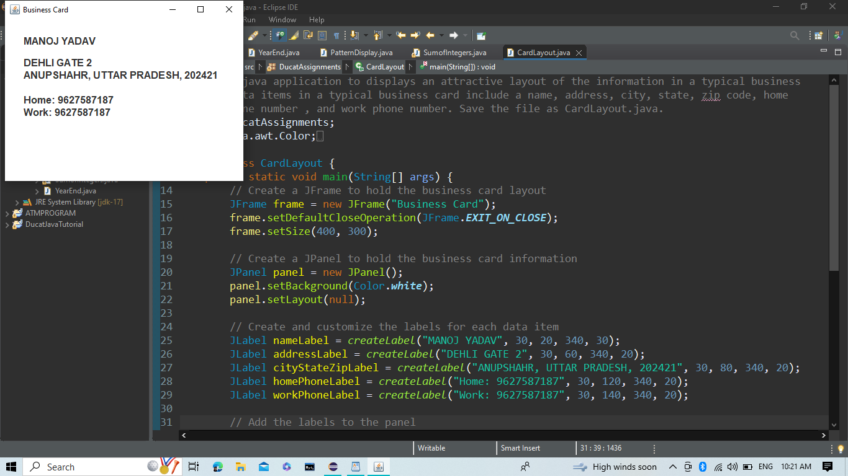

7 **.//Write a program that accepts a temperature in**

**Fahrenheit from a user and convert it to Celsius by**

**//subtracting 32 from the Fahrenheit value and**

**multiplying the result by 5/9. Display both values.**

**//save the class as FahrenheitToCelsius.java.**

**package DucatAssignments;**

**import java.util.Scanner;**

**public class FahrenheitToCelsius {**

**public static void main(String[] args) {**

**Scanner scanner = new Scanner(System.in);**

**System.out.print("Enter temperature in**

**Fahrenheit: ");**

**double fahrenheit = scanner.nextDouble();**

**double celsius = (fahrenheit - 32) * 5 / 9;**

**System.out.println("Temperature in Fahrenheit: "**

**+ fahrenheit);**

**System.out.println("Temperature in Celsius: " +**

**celsius);**

**}**

**}**

**OUTPUT**

**Enter temperature in Fahrenheit: 100**

**Temperature in Fahrenheit: 100.0**

**Temperature in Celsius: 37.77777777777778**

8 **.//Create an application named TestMethodswhose**

**main() //method holds two integers variables.**

**// Assign values to the variables. In turn, pass each**

**//value to methods named displayIt(),**

**//displayItTimesTwo(), and displayItPlusOneHundred().**

**//Create each method to perform the task**

**//its name implies . save the application as**

**//TestMethods.java.**

**package DucatAssignments;**

**public class TestMethods {**

**public static void main(String[] args) {**

**int num1 = 5;**

**int num2 = 10;**

**displayIt(num1);**

**displayIt(num2);**

**displayItTimesTwo(num1);**

**displayItTimesTwo(num2);**

**displayItPlusOneHundred(num1);**

**displayItPlusOneHundred(num2);**

**}**

**public static void displayIt(int num) {**

**System.out.println("Displaying: " + num);**

**}**

**public static void displayItTimesTwo(int num) {**

**int result = num * 2;**

**System.out.println("Displaying " + num + " times**

**two: " + result);**

**}**

**public static void displayItPlusOneHundred(int num)**

**{**

**int result = num + 100;**

**System.out.println("Displaying " + num + " plus**

**one hundred: " + result);**

**}**

**}**

**OUTPUT**

**Displaying: 5**

**Displaying: 10**

**Displaying 5 times two: 10**

**Displaying 10 times two: 20**

**Displaying 5 plus one hundred: 105**

**Displaying 10 plus one hundred: 110**

9 **.//Write an application that calculates and displays**

**the amount of money a user would have if his or**

**//her money could be invested at 5% interest for one**

**year. Create a method that prompts the user for**

**//the starting value of the investment and returns it to**

**the calling program. Call a separate method**

**//to do the calculation and return the result to be**

**displayed. save the program as interest.java.**

**package DucatAssignments;**

**import java.util.Scanner;**

**public class Interest {**

**public static void main(String[] args) {**

**double startingValue = getStartingValue();**

**double finalAmount =**

**calculateInterest(startingValue);**

**displayResult(startingValue, finalAmount);**

**}**

**public static double getStartingValue() {**

**Scanner scanner = new Scanner(System.in);**

**System.out.print("Enter the starting value of**

**the investment: ");**

**return scanner.nextDouble();**

**}**

**public static double calculateInterest(double**

**startingValue) {**

**double interestRate = 0.05; // 5% interest rate**

**double interest = startingValue * interestRate;**

**return startingValue + interest;**

**}**

**public static void displayResult(double**

**startingValue, double finalAmount) {**

**System.out.println("Starting value: ₹" +**

**startingValue);**

**System.out.println("Interest earned: ₹" +**

**(finalAmount - startingValue));**

**System.out.println("Final amount after one year:**

**₹" + finalAmount);**

**}**

**}**

**OUTPUT**

**Enter the starting value of the investment: 1000**

**Starting value: ₹1000.0**

**Interest earned: ₹50.0**

**Final amount after one year: ₹1050.0**

10 **(a).//Create a class named Invoice that contains**

**fields for an item number, name, quantity, price, and**

**//total cost. Create instance methods that set the item**

**name, quantity, and price. Whenever the price**

**//or quantity is set, recalculate the total(price times**

**quantity). Also include a displayLine() method**

**//that displays the item number, name, quantity, price,**

**and total cost. Save the class as Invoice.java**

**package DucatAssignments;**

**public class Invoice {**

**private int itemNumber;**

**private String itemName;**

**private int quantity;**

**private double price;**

**private double totalCost;**

**public void setItemName(String name) {**

**this.itemName = name;**

**}**

**public void setQuantity(int quantity) {**

**this.quantity = quantity;**

**calculateTotalCost();**

**}**

**public void setPrice(double price) {**

**this.price = price;**

**calculateTotalCost();**

**}**

**private void calculateTotalCost() {**

**this.totalCost = this.quantity * this.price;**

**}**

**public void displayLine() {**

**System.out.println("Item Number: " +**

**itemNumber);**

**System.out.println("Item Name: " + itemName);**

**System.out.println("Quantity: " + quantity);**

**System.out.println("Price: ₹" + price);**

**System.out.println("Total Cost: ₹" + totalCost);**

**}**

**}**

(b).**Create a class named TestInvoicewhose main() method**

**declares three Invoice items. Create a method that**

**prompts the user for and accepts values for the item**

**number, name, quantity, and price for each Invoice. Then**

**display each completed object. Save the application as**

**TestInvoice.java.**

**package DucatAssignments;**

**import java.util.Scanner;**

**public class TestInvoice {**

**public static void main(String[] args) {**

**Scanner scanner = new Scanner(System.in);**

**// Declare three Invoice objects**

**Invoice invoice1 = new Invoice();**

**Invoice invoice2 = new Invoice();**

**Invoice invoice3 = new Invoice();**

**// Prompt the user for input and set values for**

**invoice1**

**System.out.println("Enter details for Invoice**

**1:");**

**System.out.print("Item Number: ");**

**int itemNumber1 = scanner.nextInt();**

**scanner.nextLine(); // Consume the newline**

**character**

**System.out.print("Item Name: ");**

**String itemName1 = scanner.nextLine();**

**System.out.print("Quantity: ");**

**int quantity1 = scanner.nextInt();**

**System.out.print("Price: ");**

**double price1 = scanner.nextDouble();**

**invoice1.setItemName(itemName1);**

**invoice1.setQuantity(quantity1);**

**invoice1.setPrice(price1);**

**// Prompt the user for input and set values for**

**invoice2**

**System.out.println("\nEnter details for Invoice**

**2:");**

**System.out.print("Item Number: ");**

**int itemNumber2 = scanner.nextInt();**

**scanner.nextLine(); // Consume the newline**

**character**

**System.out.print("Item Name: ");**

**String itemName2 = scanner.nextLine();**

**System.out.print("Quantity: ");**

**int quantity2 = scanner.nextInt();**

**System.out.print("Price: ");**

**double price2 = scanner.nextDouble();**

**invoice2.setItemName(itemName2);**

**invoice2.setQuantity(quantity2);**

**invoice2.setPrice(price2);**

**// Prompt the user for input and set values for**

**invoice3**

**System.out.println("\nEnter details for Invoice**

**3:");**

**System.out.print("Item Number: ");**

**int itemNumber3 = scanner.nextInt();**

**scanner.nextLine(); // Consume the newline**

**character**

**System.out.print("Item Name: ");**

**String itemName3 = scanner.nextLine();**

**System.out.print("Quantity: ");**

**int quantity3 = scanner.nextInt();**

**System.out.print("Price: ");**

**double price3 = scanner.nextDouble();**

**invoice3.setItemName(itemName3);**

**invoice3.setQuantity(quantity3);**

**invoice3.setPrice(price3);**

**// Display each completed object**

**System.out.println("\nInvoice 1:");**

**invoice1.displayLine();**

**System.out.println("\nInvoice 2:");**

**invoice2.displayLine();**

**System.out.println("\nInvoice 3:");**

**invoice3.displayLine();**

**}**

**}**

**OUTPUT**

**Enter details for Invoice 1:**

**Item Number: 1**

**Item Name: PIZZA**

**Quantity: 2**

**Price: 120**

**Enter details for Invoice 2:**

**Item Number: 2**

**Item Name: BURGER**

**Quantity: 2**

**Price: 80**

**Enter details for Invoice 3:**

**Item Number: 3**

**Item Name: DOSA**

**Quantity: 2**

**Price: 100**

**Invoice 1:**

**Item Number: 0**

**Item Name: PIZZA**

**Quantity: 2**

**Price: ₹120.0**

**Total Cost: ₹240.0**

**Invoice 2:**

**Item Number: 0**

**Item Name: BURGER**

**Quantity: 2**

**Price: ₹80.0**

**Total Cost: ₹160.0**

**Invoice 3:**

**Item Number: 0**

**Item Name: DOSA**

**Quantity: 2**

**Price: ₹100.0**

**Total Cost: ₹200.0**